Database System Engineering and Distributed Backend Development
Course Code: 25CS13002E
DDL, DML, DCL, TCL COMMANDS 2520030527
K.Vansika Reddy
Query 1: Create Database
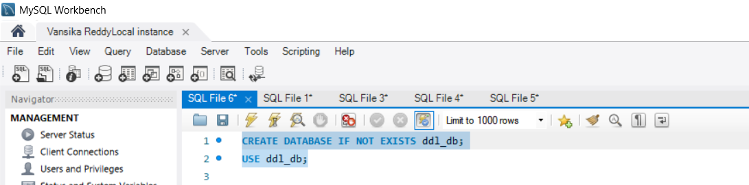

OUTPUT

Query 2: Create Table
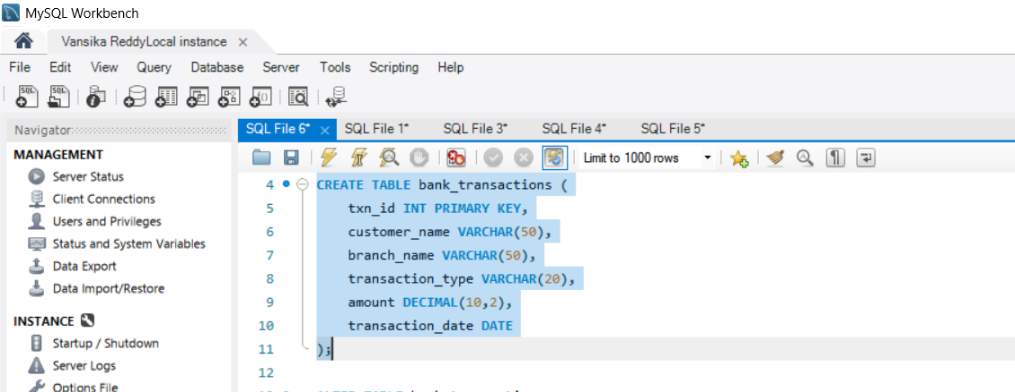

OUTPUT
Query 3: Alter Table Add Column
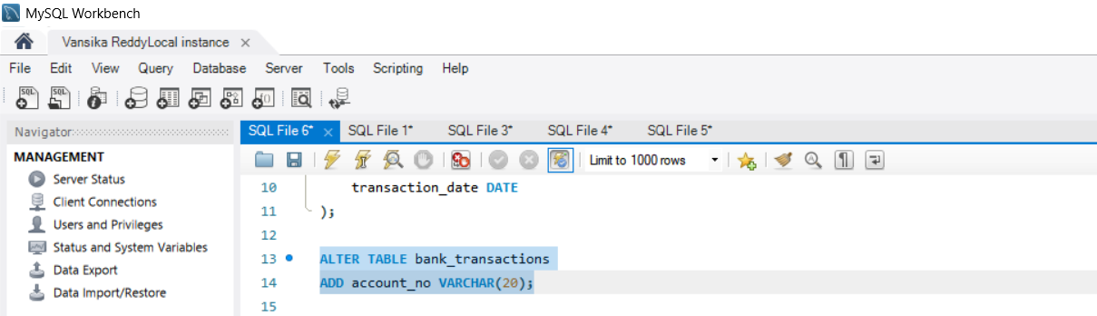

OUTPUT

Query 4: Alter Table Modify Column
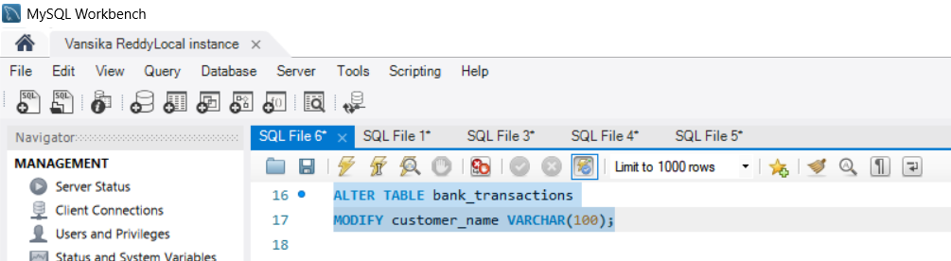

OUTPUT
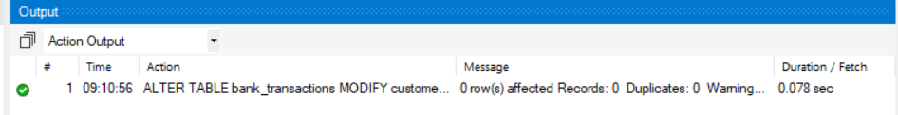

Query 5: Rename Table
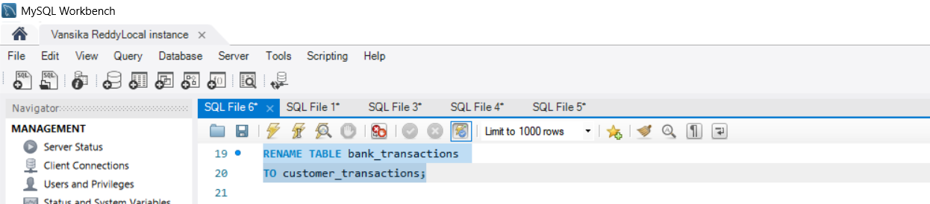

OUTPUT

Query 6: Truncate table
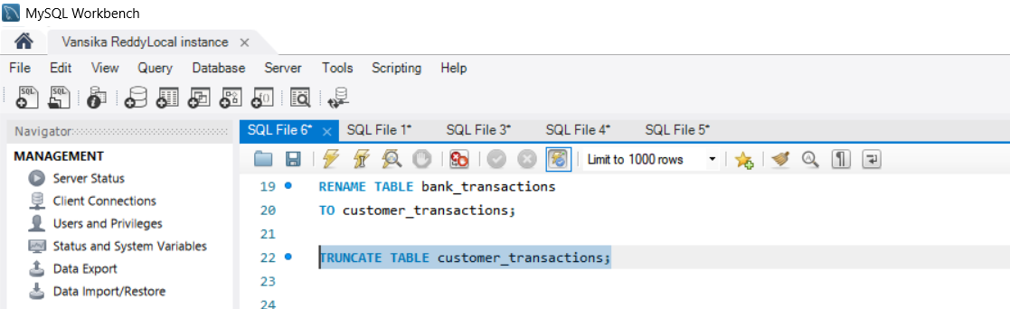

OUTPUT

Query 7: Drop a Table
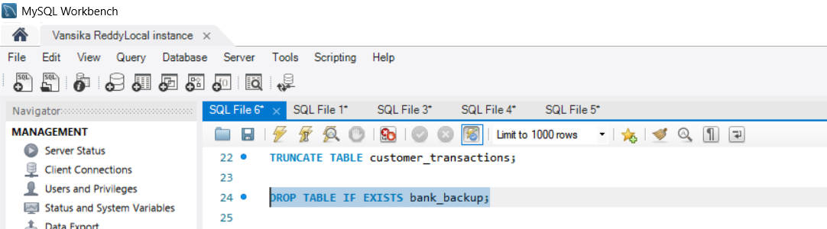
SECTION: DML Manupulation
Query 8: Insert Sample Data
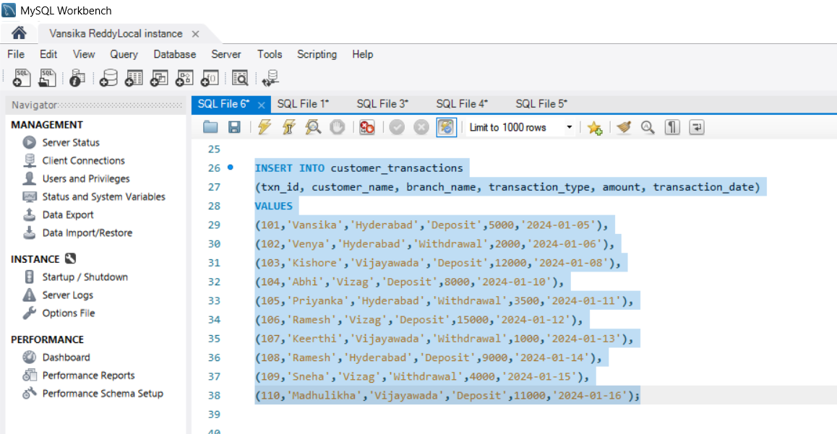

OUTPUT

Query 9: Update
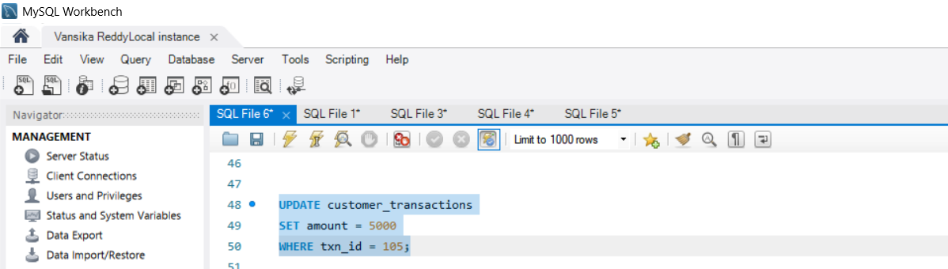

Output

Query 10: Delete
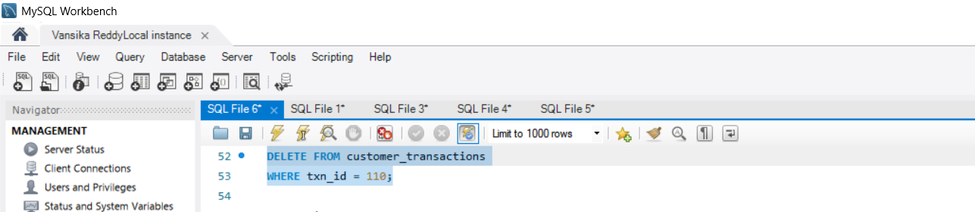

Output

Query 11: Select
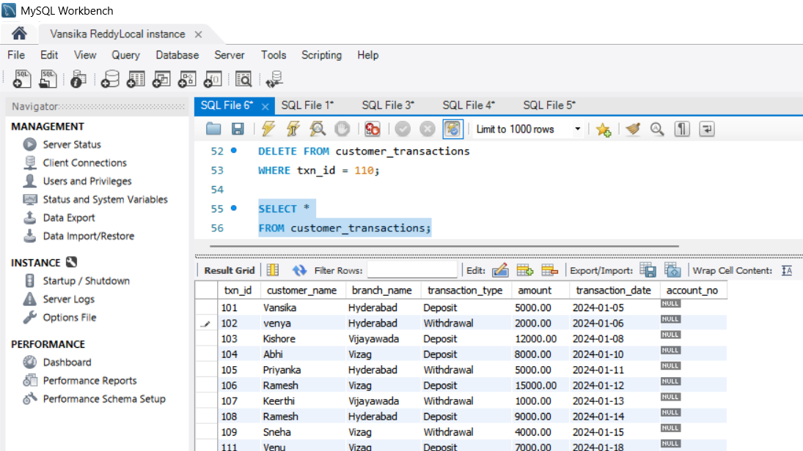
Output
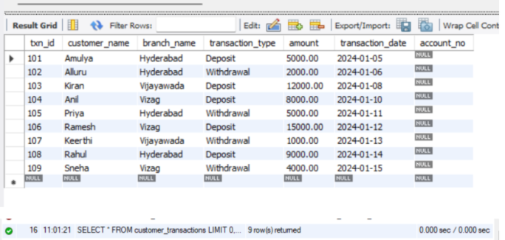

Query 12: Select With Where
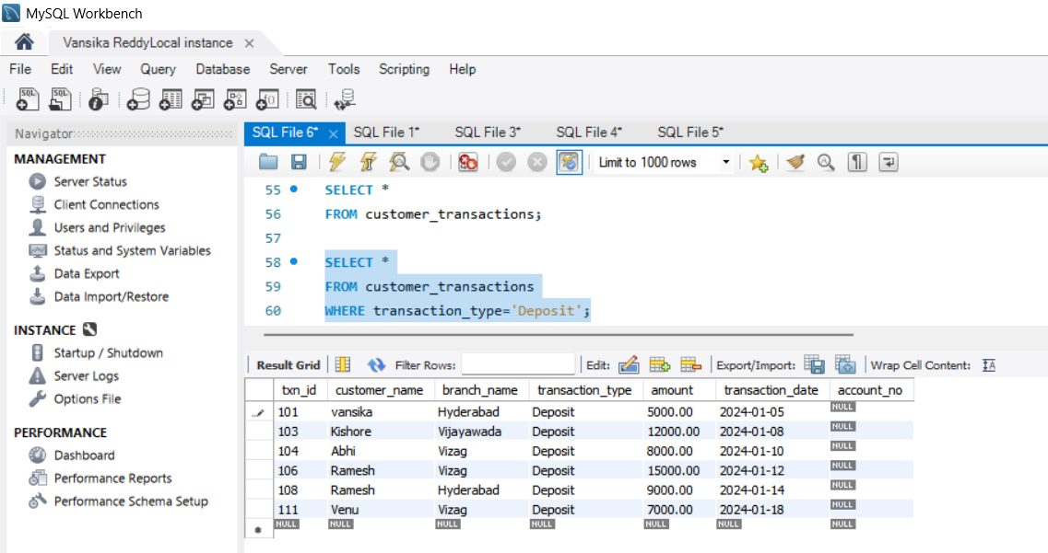

Output
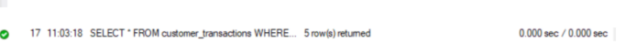
Query 13: Select With Order By
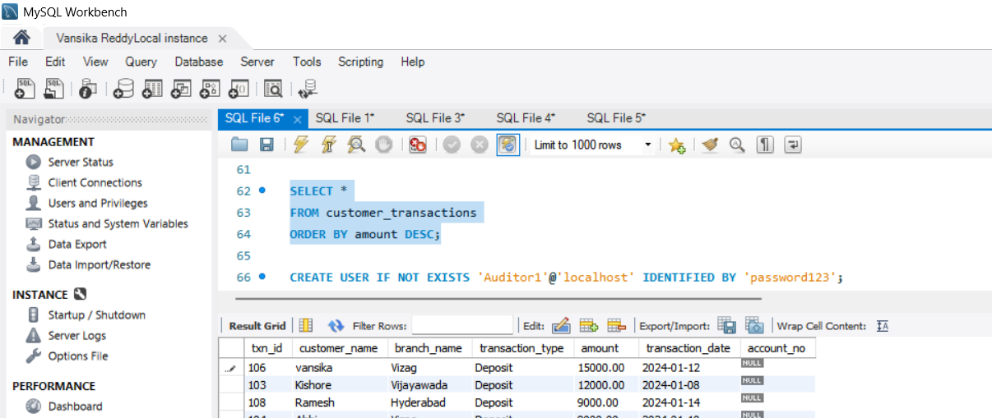

Output
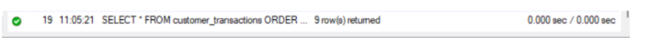
Section 3: DCL (Data Control Language)
Query 14: Grant Select
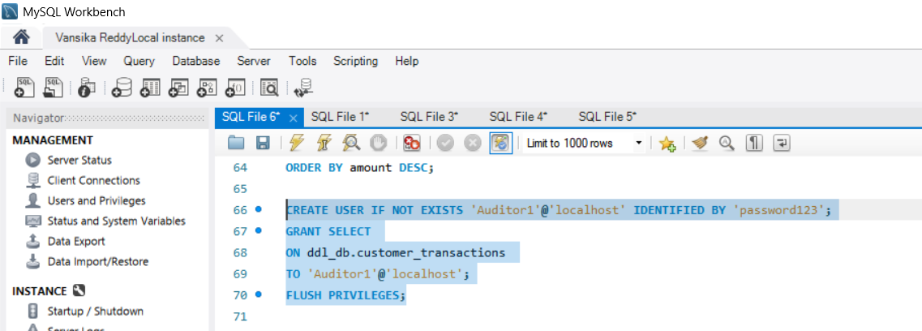

OUTPUT
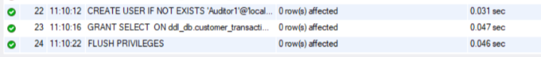

Query 15: Grant All Privileges
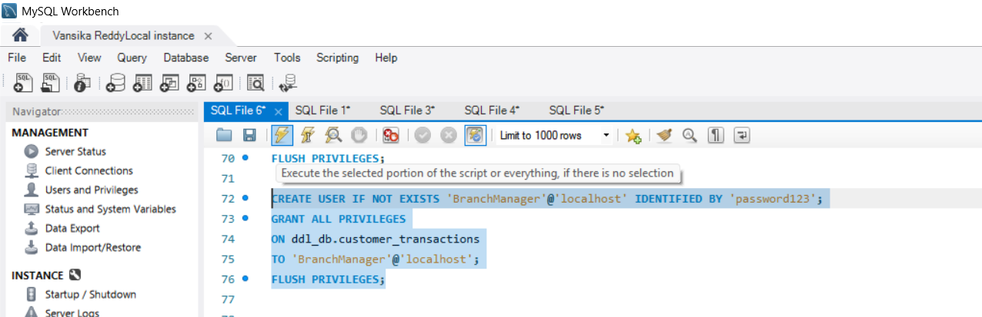

Output
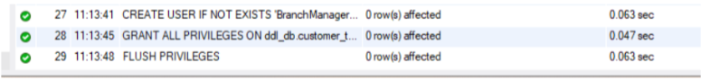

Query 16: Revoke Select
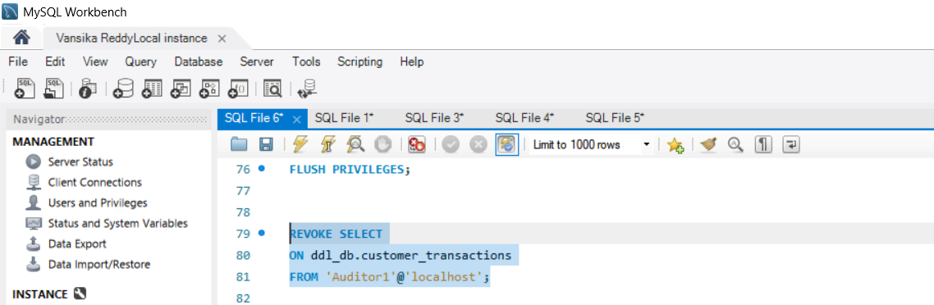

Output

Query 17: Revoke All
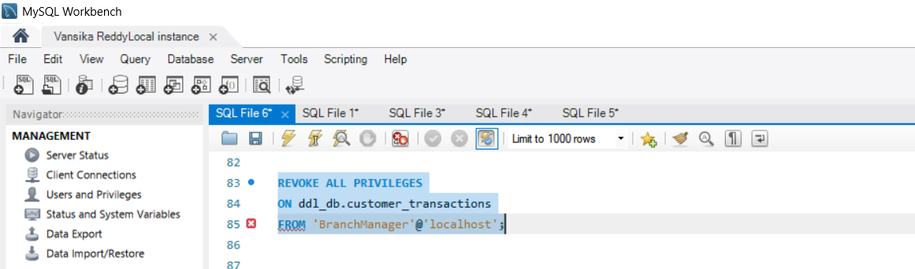

Output

Section 4: TCL (Transaction Control Language)
Query 18: Commit
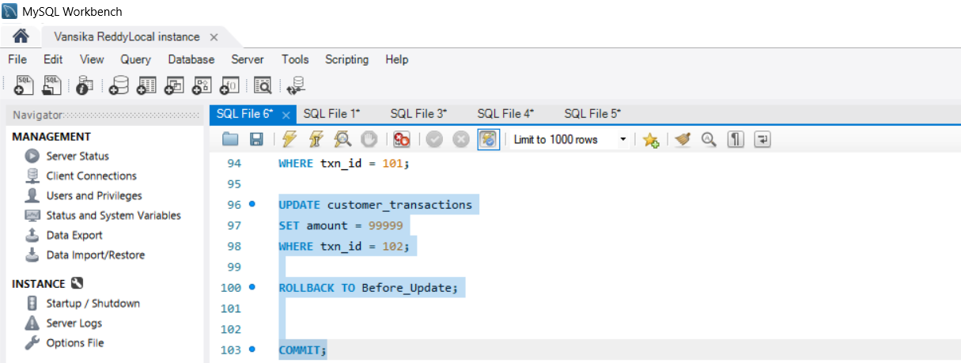

Output
Query 19: SAVEPOINT
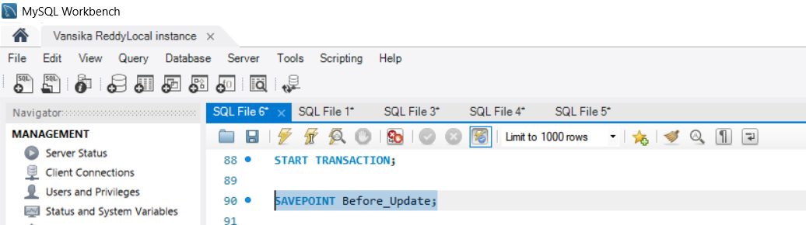

Output

Query 20: ROLLBACK To SAVEPOINT
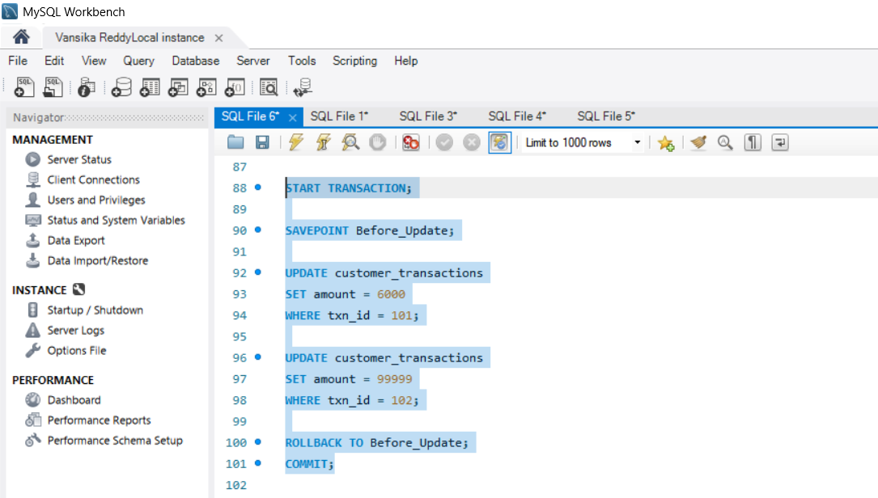
Output
